ULISES V5000i V2.6.X

Technical Manual

Operator Position User Manual

DT-A42-MTDT-01-26S0 ****

DOCUMENT REGISTRATION AND CONTROL

|  |  |  |  |
| --- | --- | --- | --- |
| **PROJECT/UNIT** | ULISES V5000i V2.6.X | ***Reference*** |  |
| **DOCUMENT** | Operator Position User Manual | ***Code*** | DT-A42-MTDT-01-26S0 |
|  |  | ***Date*** | 03/06/2020 |

|  |  |  |
| --- | --- | --- |
| **CREATED BY** |  |  |
| **DATE** |  |
| **REVIEWED BY** |  |  |
| **DATE** |  |
| **VALIDATED BY** |  |  |
| **DATE** |  |

CHANGE LOG

|  |  |  |  |
| --- | --- | --- | --- |
| **R** | **Date** | **Description** | **Author** |
|  |  |  |  |
| 1 |  | Original Version |  |
| 2 | 17-04-2013 | New functions for RABAT:  Local Recording.  BRIEFING. |  |
| 3 | 31/07/2014 | Adaptation Ulises 5000-I |  |
| 4 | 22/10/2015 | Secure Telephony on external IP Units |  |
| 5 | 07/03/2016 | AENA Manual |  |
| 6 | 05/10/2016 | Revision for version 2.5.2 |  |
| 7 | 16/01/2017 | Revision for version 2.5.3 |  |
| 8 | 13/12/2017 | Revision for version 2.5.6 | Arturo García |
|  |  | Unification of the user interface between ENAIRE and ASECNA included |  |
| 9 | 14/11/2018 | Revision for version 2.5.9 | Arturo García |
| 10 | 19/02/2019 | Emergency mode signalling (no proxy)  Unification with the ENNA manual | B. Santamaría |
|  | 05/03/2019 | Capture function | B. Santamaría |
| 11 | 10/02/2020 | Revision for version 2.6.0 | Arturo García |
|  |  |  |  |
|  |  |  |  |
|  |  |  |  |
|  |  |  |  |
|  |  |  |  |
|  |  |  |  |
|  |  |  |  |
|  |  |  |  |
|  |  |  |  |
|  |  |  |  |
|  |  |  |  |

TABLE OF CONTENTS

[1. Introduction 9](#_Toc62922129)

[2. General Format of the Screen 10](#_Toc62922130)

[2.1. General Information Panel or Header 10](#_Toc62922131)

[2.2. Radio panel 10](#_Toc62922132)

[2.3. Telephony Panel 11](#_Toc62922133)

[2.4. Hotline Panel 13](#_Toc62922134)

[3. General operation 14](#_Toc62922135)

[3.1. Client logo 14](#_Toc62922136)

[3.2. Date and Time 14](#_Toc62922137)

[3.3. JACKS and SPLIT indicators 14](#_Toc62922138)

[3.4. SPLIT Control 14](#_Toc62922139)

[3.5. INFO Key 15](#_Toc62922140)

[3.6. BRIEFING 15](#_Toc62922141)

[3.7. Messages Window 15](#_Toc62922142)

[3.8. BRIGHTNESS CONTROL 15](#_Toc62922143)

[3.9. RING Volume 15](#_Toc62922144)

[3.10. Bad Operation 16](#_Toc62922145)

[3.11. Cleaning Mode 16](#_Toc62922146)

[3.12. No JACKS in panel 16](#_Toc62922147)

[3.13. Unconfigured panel 17](#_Toc62922148)

[3.14. Operation in the emergency mode 18](#_Toc62922149)

[4. Radio operation 19](#_Toc62922150)

[4.1. General concepts 19](#_Toc62922151)

[4.2. Volume control of the radio headSeT and speaker 20](#_Toc62922152)

[4.3. Control of radio pagination 20](#_Toc62922153)

[4.4. Radio channels area 20](#_Toc62922154)

[4.5. Radio channel modes 21](#_Toc62922155)

[4.6. Radio channel statuses 22](#_Toc62922156)

[4.7. Transitions between modes 23](#_Toc62922157)

[4.7.1. VHF Channel 23](#_Toc62922158)

[4.7.2. HF Channel 24](#_Toc62922159)

[4.8. Radio Facilities 26](#_Toc62922160)

[4.8.1. PTT. Software Transmission Control. 26](#_Toc62922161)

[4.8.2. Rtx. Control of Retransmission Programming. 26](#_Toc62922162)

[4.8.3. Selective call 26](#_Toc62922163)

[5. Telephony Operation 28](#_Toc62922164)

[5.1. Direct Access Button Area 28](#_Toc62922165)

[5.2. Telephony Functions Area 29](#_Toc62922166)

[5.2.1. Hold Function 29](#_Toc62922167)

[5.2.2. Priority Function 30](#_Toc62922168)

[5.2.3. Intrusion 30](#_Toc62922169)

[5.2.3.1. Priority intrusion on a secure line (only in version 2.5.4 to 2.5.8) 30](#_Toc62922170)

[5.2.4. Listening Function 31](#_Toc62922171)

[5.2.5. Transfer Function 31](#_Toc62922172)

[5.2.6. Conference Call Function 32](#_Toc62922173)

[5.2.7. Capture function 32](#_Toc62922174)

[5.2.8. Global key for Indirect/Direct Access Control 33](#_Toc62922175)

[5.2.9. Cancel Hang up Key 35](#_Toc62922176)

[5.2.10. Hands-free telephony key 35](#_Toc62922177)

[5.3. Indirect Access Control Window (IA) 35](#_Toc62922178)

[5.3.1. Management of Recent Calls 36](#_Toc62922179)

[5.3.2. Management of Outgoing Calls 36](#_Toc62922180)

[5.4. Dependencies-User 38](#_Toc62922181)

[5.4.1. Call log 40](#_Toc62922182)

[5.5. Statuses of the PICK-UP key 40](#_Toc62922183)

[5.6. Volume Control Area 41](#_Toc62922184)

[5.6.1. Volume of Hotline and Telephony Speaker 41](#_Toc62922185)

[5.6.2. Telephony Headset Volume 41](#_Toc62922186)

[5.7. Control of Pages in Direct Access Telephony 41](#_Toc62922187)

[6. Hotline Operation 43](#_Toc62922188)

[6.1. Hotline Selection Area 43](#_Toc62922189)

[6.2. Operation through Hotline 44](#_Toc62922190)

[6.2.1. Transmission by HL 44](#_Toc62922191)

[6.2.2. Reception by HL 44](#_Toc62922192)

[7. Special Functions 46](#_Toc62922193)

[7.1. Local recording on terminal 46](#_Toc62922194)

[7.1.1. Session Recording 46](#_Toc62922195)

[7.1.2. Session Replay 46](#_Toc62922196)

[7.2. BRIEFING function 47](#_Toc62922197)

[8. Annexes 49](#_Toc62922198)

[8.1. Screenshots in ENGLISH 49](#_Toc62922199)

[8.2. Screenshots in FRENCH 49](#_Toc62922200)

[9. Legal Information 60](#_Toc62922201)

[10. GLOSSARY 62](#_Toc62922202)

INDEX OF FIGURES

[Figure 1. General Screen Format in the ENAIRE interface. 10](#_Toc62922203)

[Figure 2. General Screen Format in the ASECNA interface. 10](#_Toc62922204)

[Figure 3. General Information Area or Header in the ENAIRE interface. 10](#_Toc62922205)

[Figure 4. General Information Area or Header in the ASECNA interface. 10](#_Toc62922206)

[Figure 5. Radio panel in the ENAIRE interface. 11](#_Toc62922207)

[Figure 6. Radio panel in the ASECNA interface. 11](#_Toc62922208)

[Figure 7. Telephony panel in the ENAIRE interface. 12](#_Toc62922209)

[Figure 8. Telephony panel in the ASECNA interface. 12](#_Toc62922210)

[Figure 9. Telephony Page. Indirect access control in the ENAIRE interface. 13](#_Toc62922211)

[Figure 10. Telephony Page. Indirect access control in the ASECNA interface. 13](#_Toc62922212)

[Figure 11. Hotline Panel in the ENAIRE interface. 13](#_Toc62922213)

[Figure 12. Hotline Panel in the ASECNA interface. 13](#_Toc62922214)

[Figure 13. Messages Window. 15](#_Toc62922215)

[Figure 14. Brightness Control 15](#_Toc62922216)

[Figure 15. RING Volume Control. 16](#_Toc62922217)

[Figure 16. RING Off. 16](#_Toc62922218)

[Figure 17. Indication of Bad Operations 16](#_Toc62922219)

[Figure 18. Cleaning Mode Control 16](#_Toc62922220)

[Figure 19. Screensaver 17](#_Toc62922221)

[Figure 20. Terminal Out of Sectorization in the ENAIRE interface. 17](#_Toc62922222)

[Figure 21. Terminal Out of Sectorization in the ASECNA interface. 17](#_Toc62922223)

[Figure 22. Emergency mode position in the ENAIRE interface. 18](#_Toc62922224)

[Figure 23. Normal mode position in the ENAIRE interface. 18](#_Toc62922225)

[Figure 24. Control of Radio Headset and Speaker Volume in the ENAIRE interface. 20](#_Toc62922226)

[Figure 25. Control of Radio Headset and Speaker Volume in the ASECNA interface. 20](#_Toc62922227)

[Figure 26. Radio Pagination Controls. 20](#_Toc62922228)

[Figure 27. Page Indication. 20](#_Toc62922229)

[Figure 28. Layout of a conventional Radio Key. 21](#_Toc62922230)

[Figure 29. Layout of an HF Radio Key. 21](#_Toc62922231)

[Figure 30 . Layout of a conventional Radio Key. 21](#_Toc62922232)

[Figure 31. Controls associated with Radio Facilities 26](#_Toc62922233)

[Figure 32. Control of Retransmission Programming. 26](#_Toc62922234)

[Figure 33. Button to access the selective call area. 27](#_Toc62922235)

[Figure 34. Selective call area 27](#_Toc62922236)

[Figure 35. Selection of tones to make SEL-CAL 27](#_Toc62922237)

[Figure 36 . Control of Telephony Functions in ENAIRE interfaces. 29](#_Toc62922238)

[Figure 37. Control of Telephony Functions in ASECNA interfaces. 29](#_Toc62922239)

[Figure 38. Control of Telephony Functions with the telephone communications via speaker enabled 29](#_Toc62922240)

[Figure 39. Hands-free telephony key 35](#_Toc62922241)

[Figure 40. IA Control Window in ENAIRE interfaces. 36](#_Toc62922242)

[Figure 41. IA Control Window in ASECNA interfaces. 36](#_Toc62922243)

[Figure 42. Recent Calls. 36](#_Toc62922244)

[Figure 43. IA Page. MEM Key in ENAIRE interfaces. 37](#_Toc62922245)

[Figure 44. IA Page. MEM Key in ASECNA interfaces. 37](#_Toc62922246)

[Figure 45. Directory of Dependencies and Users. Scenario 1 in ENAIRE interfaces. 38](#_Toc62922247)

[Figure 46. Directory of Dependencies and Users. Scenario 1 in ASECNA interfaces. 38](#_Toc62922248)

[Figure 47. Directory of Dependencies and Users. Scenario 2 in ENAIRE interfaces. 38](#_Toc62922249)

[Figure 48 Directory of Dependencies and Users. Scenario 2 in ASECNA interfaces. 38](#_Toc62922250)

[Figure 49. Directory of Dependencies and Users. Scenario 3 in ENAIRE interfaces. 39](#_Toc62922251)

[Figure 50 Directory of Dependencies and Users. Scenario 3 in ASECNA interfaces. 39](#_Toc62922252)

[Figure 51. Directory of Dependencies and Users. Scenario 4 in ENAIRE interfaces. 39](#_Toc62922253)

[Figure 52 Directory of Dependencies and Users. Scenario 4 in ASECNA interfaces. 39](#_Toc62922254)

[Figure 53. Log of incoming, outgoing and unanswered calls. 40](#_Toc62922255)

[Figure 54. Hotline Speaker Volume Control 41](#_Toc62922256)

[Figure 55. Telephony Speaker Volume Control 41](#_Toc62922257)

[Figure 56. Volume Control of Telephony Headset 41](#_Toc62922258)

[Figure 57. Control of Telephony Pagination in ENAIRE interfaces. 41](#_Toc62922259)

[Figure 58. Control of Telephony Pagination in ASECNA interfaces. 41](#_Toc62922260)

[Figure 59. Local Replay on the Terminal, Standby and Replay 47](#_Toc62922261)

[Figure 60. BRIEFING Function 47](#_Toc62922262)

INDEX OF TABLES

[Table 1. Indication of Status, Client logo 14](#_Toc62922263)

[Table 2. Indication of JACK Status. 14](#_Toc62922264)

[Table 3. Indication of SPLIT Mode. 14](#_Toc62922265)

[Table 4. General concepts 19](#_Toc62922266)

[Table 5. Indication of Radio Channel modes 22](#_Toc62922267)

[Table 6. Indication of Radio Channel Statuses 23](#_Toc62922268)

[Table 7. PTT Control. 26](#_Toc62922269)

[Table 8. Telephony Terminal Statuses 29](#_Toc62922270)

[Table 9. Hold Control Status. 29](#_Toc62922271)

[Table 10. Priority Control. 30](#_Toc62922272)

[Table 11. LISTENING Control Statuses 31](#_Toc62922273)

[Table 12. TRANSFER Control Statuses 32](#_Toc62922274)

[Table 13. Control Statuses of the CONFERENCE CALL. 32](#_Toc62922275)

[Table 14. Capture control states 33](#_Toc62922276)

[Table 15. IA Key Indications 34](#_Toc62922277)

[Table 16. CANCEL Key statuses in ENAIRE interfaces. 35](#_Toc62922278)

[Table 17. CANCEL Key statuses in ASECNA interfaces. 35](#_Toc62922279)

[Table 18. Hang up / Pick up statuses. 41](#_Toc62922280)

[Table 19. Status of the Pagination Keys 42](#_Toc62922281)

[Table 20. Operational Statuses of Hotlines 43](#_Toc62922282)

[Table 21. Procedure for Transmission by HL 44](#_Toc62922283)

[Table 22. Procedure for Reception by HL 45](#_Toc62922284)

[Table 23. Glossary of Abbreviations 64](#_Toc62922285)

# Introduction

“HMI.EXE” is an application that provides VCS end users with the means needed to use the telephony and radio resources supplied by this system.

Its main purpose is to provide users of the ULISES V 5000 system with an intuitive and direct environment for operation, within the limitations that a computer presents, in addition to giving more information and quick access to that information.

The application is designed to use TFT and touchscreen technologies to the maximum advantage to allow users to access the desired functions quickly.

This application can be configured (during installation) to display one of the following types of interfaces:

* ENAIRE Interface. Adapts to the sizes and functions of ENAIRE specification for Control TOWERS in Spain.
* ASECNA interface. Adapts to the dimensions and functions of the requirements established by ASECNA for its air navigation management centres (Control Centres and Towers).

# General Format of the Screen

The general format of the screen is divided into the following areas:

* General information panel or Header
* Radio panel
* Telephony panel
* Hotline panel

The following figures show the format of the FAA interfaces.

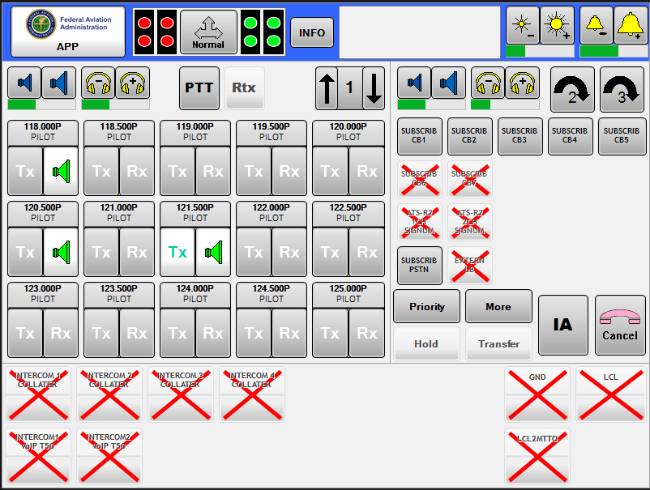

Figure 1. General Screen Format in the **FAA** interface.

Each of these interfaces has specific features for each of the areas that make it up.

## General Information Panel or Header

It is at the top of the screen. It is shown in the figure below:



Figure 3. General Information Area or Header in the FAA interface.

This panel is divided into the following zones:

* Application logo
* Presence of JACKS and SPLIT control
* Telephony Information Key
* Messages Window
* Brightness Control
* RING Volume Control

## Radio panel

It occupies the central left part of the screen and provides the controls for operating the radio sub-system. It is shown in the figure below:

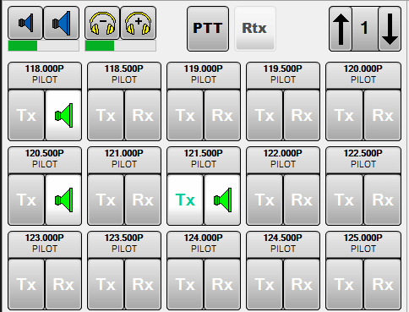

Figure 5. Radio panel in the FAA interface.

This panel contains the following elements:

* Control of radio speaker volume
* Control of headset volume
* PTT Software Key
* RTX Group function Key
* Radio Pages Control
* Radio Position Access Area (up to 15 per page)

## Telephony Panel

It occupies the central right part of the screen and provides the controls for operating the telephony with previous call sub-system. It is shown in the figure below:

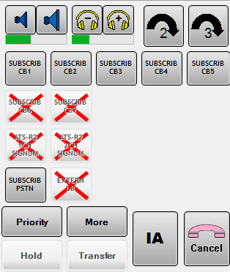

Figure 7. Telephony panel in the FAA interface

The criteria for the organisation of the DAs in the panels with grouped sectors are:

* 1. The keys of the first sector (lowest SACTA Id.) that makes up the grouping in its original position.
* 2. The keys of the rest of the sectors in the available gaps.
* 3. If the entire panel is already occupied, the keys with the lowest priority will be eliminated.

In addition to this, the Indirect Access screen shown below will be superimposed on the central part:

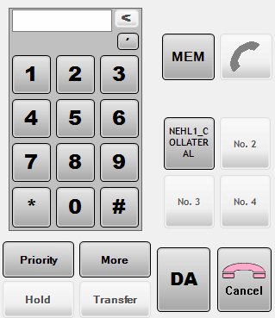

Figure 9. Telephony Page. Indirect access control in the FAA interface.

This screen contains the following elements:

* Phone dialler, which consists of the corresponding keypad, delete key, pause and DISPLAY.
* MEM key to access the telephone directory
* Pick up/hang up key
* Call log keys
* Telephony functions area. This last zone shows a different format for each one of the interfaces shown in figures 7 and 8.

## Hotline Panel

It occupies the bottom of the screen and offers the operation control for the Hotline sub-system. It is shown in the figure below:

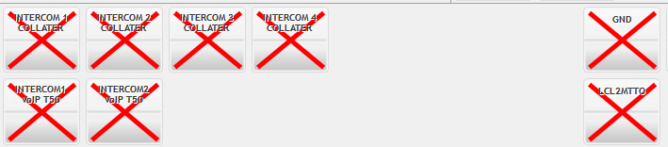

Figure 11. Hotline Panel in the FAA interface.

The Hotline Communications Area has one single area for Hotline Selection. The Auxiliary Functions, which in this case are limited to the hotline speaker control, are included in the Volume Control Area for Auxiliary Telephony Functions.

The hotline panel in the ENAIRE interface may contain up to 20 elements, arranged in two rows, while the ASECNA interface may contain 10 elements arranged in a single row.

# General operation

It corresponds to the functions indicated or accessible through the general information panel or Header panel:

## Client logo

It displays the name of the terminal and indicates the operational status using the following colour code.

|  |  |
| --- | --- |
|  | Terminal operational. |
|  | Terminal in Cleaning Mode. |
|  | Terminal Isolated. |

Table 1. Indication of Status, Client logo

## Date and Time

This zone is available only in the ASECNA interface. It displays the local date and time of the machine where the operator terminal is running.

## JACKS and SPLIT indicators

These indicate the connection or disconnection of each pair of JACKS in the Panel. If they are inserted, they will be green, and red if not.

|  |  |
| --- | --- |
| JACKS not inserted | JACKS inserted |
| Jacks rojosJacks rojos | Jacks verdesJacks verdes |

Table 2. Indication of JACK Status.

## SPLIT Control

It indicates the status of Separation or Integration of ROLES in Terminals. When this key is pressed, a window will open that will allow the separation of Radio, Hotlines and Telephony.

|  |  |
| --- | --- |
| Normal or Integrated Mode (Instructor-Student) |  |
| Split Mode (Executive-Assistant) |  |

Table 3. Indication of SPLIT Mode.

In Normal Mode, the audio of radio, telephony and hotline will be sent to all of the JACKS that are inserted. Pressing PTT through any of them will make a radio transmission. If a PTT occurs through both JACKS, the instructor has priority over the student for transmitting the audio and in PTT-OFF.

In Split Mode, depending on the selection, the telephone and hotline communications will be sent over one of the connectors, and radio communications over the other; the PTT will be operational on this second connector.

In the other selection, the radio and hotline audio will reach and will be transmitted over a pair of connectors, and only the PTT of these connectors will be operational. The other pair will have the telephone communications.

To switch from one mode to another, at least one Jack must be inserted in each pair of connectors, and a window will open to allow the current selection to be changed after confirming the change.

In Split mode, if one of the connectors is removed, the system will return to Normal mode.

## INFO Key

The INFO control gives access to the management of telephony dependencies and call log (the latter is only in the ASECNA interface). The appearance and functions will be covered in the chapter on telephone operation.

## BRIEFING

The control labelled with a RED circle under the INFO control gives access to the BRIEFING function, which will be described in the section on special functions.

## Messages Window

This window displays the events and situations that occur during the operation of the system, such as conversations established, holds, warnings and other incidents that occur in the system.

…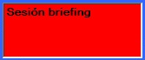

Figure 13. Messages Window.

## BRIGHTNESS CONTROL

It regulates the brightness of the screen. A short press on the left button decreases the brightness, and a short press on the right button increases it. The bar at the bottom indicates the selected level of brightness.

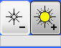

Figure 14. Brightness Control

## RING Volume

It regulates the incoming call RING Volume. A short press on the left button decreases the volume, and a short press on the right button increases it. The bar at the bottom indicates the volume level.

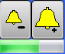

Figure 15. RING Volume Control.

A long press on this control cancels the audible signal of incoming calls, which will be indicated as shown in the figure below.

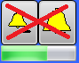

Figure 16. RING Off.

## Bad Operation

In general, if an operator executes a Bad Operation or an action that is unauthorized or not configured as explained in this document, referred to as “*Bad Operations”*, the system will immediately detect the anomaly and the normal functioning of the system will not be affected.

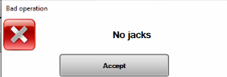

Figure 17. Indication of Bad Operations

The user will receive an audible signal indicating this. The warning that the operator will receive through the headset will be an acoustic signal indicating an incorrect action for the operation (Bad Operation). The audible tone will be superimposed on the Headset signal.

## Cleaning Mode

The purpose of the cleaning function, which is activated by pressing the upper left area of the screen, is to clean the screen.

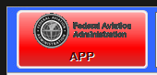

Figure 18. Cleaning Mode Control

When the button is deactivated, on a white background, cleaning cannot be done. This means that the screen is active and if it is touched, since it is a touchscreen, the keys in the Panel will be activated directly. If the button is active (as shown in the figure), the Panel screen can be cleaned. While this mode is active, communications remain active, as well as the audible signals. To reactivate the panel, reinsert the JACKS. A window indicating that cleaning mode is active will be displayed while the system is in this mode.

## No JACKS in panel

When the operator JACKS are removed from an operating position, the radio channels selected on the headset automatically switch to the speaker, and if no JACK is connected, after the number of minutes configured, they will switch to standby. Any established telephone communications will be cut off, and the retransmission groups will be undone.

If no JACKS are inserted for the configured number of minutes, the screensaver shown below will be displayed.

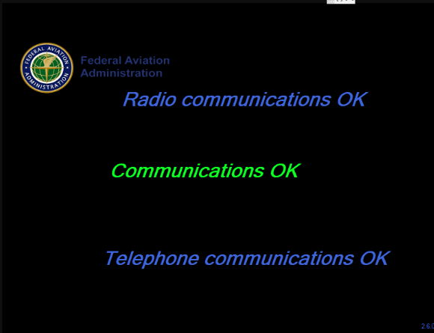

Figure 19. Screensaver

In any of these statuses, the incoming telephony audio, incoming telephone call RING and incoming Hotline audio will be sent to the terminal. Just insert any operator Jack to activate the terminal.

## Unconfigured panel

The operator terminals with no assigned SECTORS through SECTORIZATION display the following TFT panel:

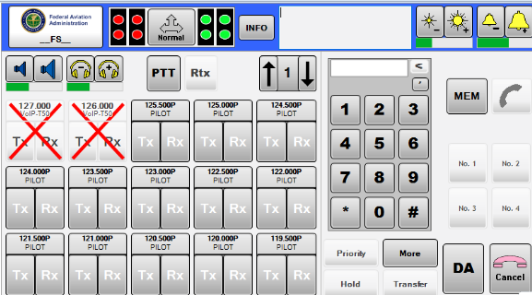

Figure 20. Terminal Out of Sectorization in the FAA interface.

As shown in the image above, **OS** (Out of Sectorization) is displayed on the terminal name. These operator terminals only have Radio resources.

## Operation in the emergency mode

The emergency mode refers to operations without an operational SIP proxy server (its configuration is required).

The proxy is configured as the VCS IP in its own routing process with the address of the main proxy server. Only the VCS internal IP hotline and telephone communications are allowed in this operating mode. With regards to external communications (for example, with other ATS destinations), no calls can be made or received towards other destinations via IP, although the analogue lines can be used for this.

This will be indicated with the background colour of the panel’s top section. Blue indicates the normal mode and yellow the emergency mode.

|  |  |
| --- | --- |
|  |  |
| Figure 22. Emergency mode position in the FAA interface. | Figure 23. Normal mode position in the FAA interface. |

# Radio operation

## General concepts

The terms that will be applied later in the text of this document are the following:

|  |  |
| --- | --- |
|  |  |
| **Assigned** | Of the Radio Units that the Supervisor has configured for the user in a particular Panel of the three that are available, those that are in one of the three rows of the four columns of the Radio Panel will be assigned in the Radio Panel. |
| **Selected** | A Radio Unit assigned in a particular Radio Panel position may be selected in three different ways:  Standby: A Radio Unit with this type of selection will only receive indicator lights in response to SQUELCH reception.  RX: A Radio Unit with this type of selection will receive indicator lights and audio signals in response to SQUELCH reception either over the speaker or headset.  TX/RX: A Radio Unit with this type of selection will receive indicator lights and audio signals in response to SQUELCH reception and also allows transmission when the operator presses PTT (PUSH TO TALK). |
| **Transmission** | A Radio Unit selected in TX, transmission, when the User presses PTT. |
| **Button/Push-button** | Each one of the Software switches available to the User on the screen to carry out the operation. |
| **DISPLAY** | Any space on the screen reserved for writing significant letters and numbers of a specific concept. There are two different displays in the Radio Panel. |
| **Identification** | The identification of a panel is the name that appears in the top left of the screen or TFT, made up of 10 alphanumeric characters. This name can be programmed from the Manager/Supervisor position. |
| **SQUELCH** | Receiving Squelch means that a Radio Unit has detected a signal on the same frequency to which it is tuned and with sufficient reception level. When a SQUELCH is detected, it triggers the Reception process of a Radio Unit in the system. |
| **Reception** | In connection with the previous concept, reception by a Radio Unit means that there is an audible signal from a Radio Unit available to the User if it has been assigned in RX or TX/RX on its panels. If standby has been selected, SQUELCH will be indicated without the audio reaching the physical means available to the User to listen to it. |

Table 4. General concepts

## Volume control of the radio headSeT and speaker

This regulates the radio speaker and headset volume. A short press on the left button decreases the volume, and a short press on the right button increases it. The bar at the bottom indicates the volume level.

|  |
| --- |
|  |
| Figure 24. Control of Radio Headset and Speaker Volume in the ENAIRE interface. |

The double radio speaker can be selected during installation for all frequencies of any interface. In this case, they will be redundant in case of failure. If one fails, the system will automatically switch to the other available speaker or to the headset if needed. When the fault disappears, the system remains unchanged. This change is not restored automatically and must be processed by the operator.

If this option is not selected, the behaviour will be different in each interface: ASECNA has a second radio speaker that is only used for HF frequencies and AENA has a single radio speaker.

During installation, the “speaker only mode” can be selected for installations with units without headset. In this case, the headset volume controls will not appear.

## Control of radio pagination

This allows the movement between the different pages configured in radio.



Figure 26. Radio Pagination Controls.

When the ‘arrow’ buttons are pressed, the display passes to the next or previous page that has radio channels configured. The central part of the key indicates the current page of the selection.



Figure 27. Page Indication.

The display will pass through the different configured radio pages. When the page is changed, all of the assigned frequencies will automatically change to STANDBY.

## Radio channels area

The central part of the Radio Panel has a window with 15 keys (TC) for selecting radio channels [5 columns x 3 rows], which include the buttons for selecting the operating modes of each assigned Radio Channel, a DISPLAY and a series of indicator lights. Channel selection is done using direct execution software buttons.

The radio panel can also contain VHF frequencies and HF frequencies. These are distinguished by the green colour of the text of the key identification area.

|  |  |
| --- | --- |
|  |  |
| Figure 28. Layout of a conventional Radio Key. | Figure 29. Layout of an HF Radio Key. |

The elements that make up the radio channel selection key are shown below:

|  |
| --- |
| Tx Control  PTT Indicator.  Frequency Identifier  RX Control  SQH Indicator |
| Figure 30 . Layout of a conventional Radio Key. |

* Frequency Identifier. This is at the top of the key and it consists of 2 lines of text and a coloured background. The first line of text indicates the frequency that identifies the channel and the second line of text identifies the operation to which the frequency is dedicated.
* Transmission Control Area. This is on the lower left side of the key; in standby, it is displayed with the text TX in white on a grey background.
* Reception Control Area. This is on the lower right side of the key; in standby, it is displayed on a grey background.
* SQUELCH and PTT indicators.

## Radio channel modes

This section describes the different modes of a radio channel and how this status is displayed on the HMI.

|  |  |
| --- | --- |
| Mode | INDICATOR |
| Channel on standby. |  |
| Channel assigned to the speaker in Rx when there is no general double radio speaker configured. |  |
| Channel assigned to the first speaker in Rx when there is a general double radio speaker configured. |  |
| Channel assigned to the second speaker in Rx when there is a general double radio speaker configured. |  |
| HF Channel assigned in Rx on HF speaker. |  |
| Channel assigned in Rx on headset. |  |
| Channel assigned in Tx/Rx on speaker. |  |
| Channel assigned in Tx/Rx on headset/microtelephone. |  |
| Channel assigned in Tx/Rx on headset and included in a retransmission group. |  |

Table 5. Indication of Radio Channel modes

## Radio channel statuses

The possible different statuses are described below:

|  |  |  |
| --- | --- | --- |
| Radio channel statuses | | |
| Status | Mode | Indication |
| Channel on standby SQUELCH ICON GREEN. | Any mode. On standby, audio does not reach the physical means available to the user to listen to it. |  |
| Channel assigned and in reception (background of the frequency indicator and the Rx indicator is WHITE and the Speaker or Headset icon). | Rx Mode, the audio reaches the headset/speaker depending on which is selected. |  |
| PTT.  Assigned and Tx Operation (PTT) only carrier. | Tx/Rx mode on speaker or headset and Rx mode on speaker or headset |  |
| Assigned and Tx Operation (PTT) only carrier, without carrier detection. | Tx/Rx mode on speaker or headset and Rx mode on speaker or headset. |  |
| External retransmission. Indicated with a black R on a red background, in the right part of the channel identification zone. | Any mode. |  |
| Channel involved in facility sequence, indicated in two ways, with a yellow background in the channel identification zone or with a flashing yellow background. | Any mode. |  |
| Channel cannot be selected (Malfunction). | Any mode. |  |
| Channel involved in Blocking/Bad Operation because the channel is in Tx by another user. | Tx/Rx mode on speaker or headset. |  |

Table 6. Indication of Radio Channel Statuses

## Transitions between modes

### VHF Channel

|  |  |
| --- | --- |
| Sequence | INDICATOR |
| Starting from standby to Rx and vice-versa: With a short press in the RX zone, carry out the following sequence: | BD21298_BD21298_BD21298_ |
| With a long press on the RX zone, with speaker or headset in RX selected, switches to standby. | BD21298_ |
|  | BD21298_ |
| Starting from Standby to Tx and vice-versa: With a short press in the TX zone, while on standby, carry out the following sequence: | BD21298_BD21298_BD21298_BD21298_ |
| With a short press in the RX zone, with TX assigned and speaker selected, carry out the following sequence: | BD21298_BD21298_BD21298_ |
| With a long press on the RX zone, with TX assigned and speaker or headset in RX selected, switches to standby. | BD21298_ |
|  | BD21298_ |

### HF Channel

|  |  |
| --- | --- |
| Sequence | INDICATOR |
| For an HF channel, starting in standby to RX and vice-versa: With a short press in the RX zone, carry out the following sequence: | BD21298_  BD21298_ BD21298_  BD21298_ |
| With a long press on the RX zone, with speaker or headset in RX selected, switches to standby. | BD21298_ |
|  | BD21298_ |
|  | BD21298_ |
| Starting from Standby to Tx and vice-versa: With a short press in the TX zone while on standby, carry out the following sequence: | BD21298_BD21298_BD21298_ BD21298_ |
| With a short press in the RX zone, with TX assigned and speaker selected, carry out the following sequence: | BD21298_BD21298_ BD21298_ |
| With a long press on the RX zone, with TX assigned and speaker or headset in RX selected, switches to standby. | BD21298_ |
|  | BD21298_ |
|  | BD21298_ |

The above diagram also applies to the general double radio speaker, replacing:

with for the first speaker and  with 

## Radio Facilities

Comprises the controls shown in the figure below:



Figure 31. Controls associated with Radio Facilities

The different functions in this area are explained below:

### PTT. Software Transmission Control.

A radio channel must be assigned in TX/RX when this key or the associated external button is pressed. If PTT is allowed, the colour of the key will change to blue, and if this is not possible, bad operation will be indicated by the bad operation tone. The indicator in the radio channel is the one described in section 2.10 of the documentation.

|  |  |
| --- | --- |
| **STANDBY** | **ACTIVE** |
|  |  |

Table 7. PTT Control.

When the key or external button is released, the key returns to standby.

### Rtx. Control of Retransmission Programming.

It makes it possible to enter channels assigned in Tx/Rx in a retransmission group. There must be at least two channels assigned in Tx/Rx, because the smallest possible group is two channels.

If there are less than two channels assigned in Tx/Rx, the key will be light grey, as shown in fig. 24

When the Rtx key is pressed, it will switch to flashing yellow, indicating the programming status of the retransmission group in progress.

When you press on a channel in the facility sequence, this is entered into the group or removed from the group, depending on its previous status.



Figure 32. Control of Retransmission Programming.

After the channels have been added to a group, when you press the Rtx key again, the changes will be made, if possible.

In an existing group, if there is a SQUELCH that is being retransmitted to the rest of the frequencies, it will not be possible to dissolve a group or to delete or add a frequency from/to the group. A pop-up window indicates the corresponding warning.

The removal of the two JACKS in the operator terminal makes it possible to dissolve a retransmission group formed previously without taking the SQUELCH condition into account.

### Selective call

The selective call function is accessed by pressing the button that is provided for this purpose at the bottom of the radio area, in the interface.



Figure 33. Button to access the selective call area.

The selective call button is only active while the operator has an HF frequency selected in TX. When this button is pressed, the selective call work area will be displayed, as shown in the figure below:

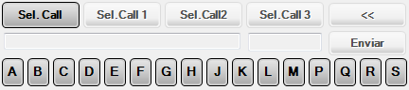

Figure 34. Selective call area

The generation of SEL-CALL tones of the HMI application of is based on the following document:

ICAO: AERONAUTICAL TELECOMMUNICATIONS, Annex 10 to the Convention on International Civil Aviation, Volume I, 4th edition of 1985 (amended 1987).

To send a SEL-CALL tone, press the keys of the letters which appear in the corresponding field:

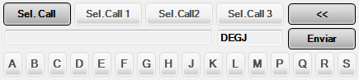

Figure 35. Selection of tones to make SEL-CAL

As shown in figure 25, after the four tones (characters) have been entered, the keys that correspond to the tones are deactivated, and on the other hand, the *SEND* key is activated and may be pressed to send the tones.

During the process of sending the selective call, messages with the call status are displayed in the information field. These messages may be:

|  |  |
| --- | --- |
| Starting SELCAL call... | The process for sending the tones is initiated. |
| Sending SELCAL tones... | The transmitter is ready to send the tones and they are sent. |
| Error in SELCAL call | The selective call ended with an error; the tones were not sent. |
| Tones selected for sending | The message that is displayed corresponds to the same tones that were to be transmitted. The selective call was completed successfully. |

If the selective call was completed successfully, the code of the transmitted tones is memorised in the buttons *Sel.Call1, Sel.Call2* and *Sel.Call3* sequentially. These buttons can be used later to select the corresponding tones and send them with the *SEND* key.

After a tone is entered, it can be deleted with the ‘<<’ key.

The selective call area is closed by pressing the *Sel. Call* button again or unassigning the HF frequency that was selected in Tx mode.

# Telephony Operation

This section describes the Characteristics/Capacities of each one of the elements and functions associated with the telephony operation.

## Direct Access Button Area

This area allows the individual selection of each available Direct Access Telephony Circuit. In the access area, there are 15 keys per page, with the last position being the same for all pages, which will be the position through which IA calls enter. There are 3 pages available, to facilitate the unique selection of each one of the 42 possible telephone lines.

Each one of these telephone line keys indicates the operational status of one line, and along with the associated function keys, implement the system operations.

The last DA key on each page is reserved for future uses.

Each telephone line key is defined by a ±16 characters ID represented on 2 lines of text, with information regarding the identification of the destination. The Key background indicates the status of the associated service according to the colour code:

|  |  |
| --- | --- |
| **STATUS** | **VIEW** |
| Standby |  |
| Incoming, Flashing Orange |  |
| Incoming Priority, Rapid Flashing Orange |  |
| Outgoing |  |
| On Hold, Flashing Green |  |
| Conversation |  |
| Memorised |  |
| Block, busy |  |
| Congestion, Flashing Red |  |
| Out of service / Destination Unreachable |  |

Table 8. Telephony Terminal Statuses

## Telephony Functions Area

This Area will allow the individual selection of all of the User Telephony Functions implemented in the system and assigned to the position.

In the Enaire interface view, all telephony functions can be accessed by pressing the "More" key. The “More” key shows the status of the hidden telephony function keys:

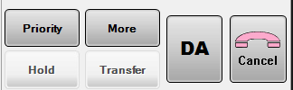

Figure 36 . Control of IA Telephony Functions in FAA interfaces.

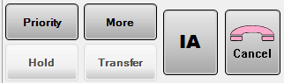

Figure 36 . Control of DA Telephony Functions in FAA interfaces.

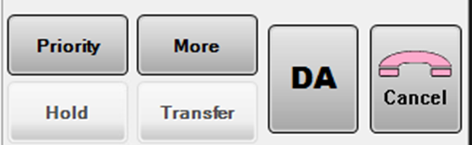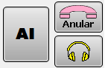

Figure 36 . Control of Telephony Functions in FAA interfaces.

### Hold Function

The hold function allows the user to temporarily disconnect an established communication in order to carry out another telephone operation and then return to the original call. A previously existing conversation is required to use this function. When this button is pressed, the conversation in progress is put on hold, with the Hold key displayed in yellow.

|  |  |
| --- | --- |
| **STATUS** | **VIEW** |
| Hold Standby |  |
| Hold Active |  |

Table 9. Hold Control Status.

The corresponding telephone access key will change from steady to flashing green. In the messages window, the line Talking with: XXXX will disappear and Holds: XXXX. will be displayed.

### Priority Function

The Priority function allows the authorised calling user to increase the priority level of his outgoing call to the Emergency level. This is only allowed for ATS destinations, not for point-to-point lines, external networks or SIP telephones.

An outgoing call for which the Priority function has previously been invoked becomes an Emergency Call.

An Emergency Call to an Operator position will be indicated by the Ulises System with a ‘priority’ ring.

An Emergency Call to an extension of the Secure Telephony Network of ULISES in BUSY status will become an INTRUSION.

An Emergency Call to the ATS Network (AGVN) will be attempted to be completed even if there are no available circuits at the origin or destination to complete the call because they are all occupied by lower priority calls.

INTERVENTION. An Outgoing Call on the ATS network with priority lower than Emergency, if it CANNOT be completed due to CONGESTION, becomes an Emergency Call when the Priority Key is pressed.

At that point, an Intervention scenario is initiated at the origin or destination. In this scenario, **a circuit occupied by a call with a priority lower than Emergency is selected** for Intervention/Interruption to complete the Priority or Emergency Call.

A warning period of 10 seconds begins during which the collaterals who are using the intervened circuit will hear an interruption warning tone consisting of an intermittent 1 KHz tone at a cadence of 500 ms ON/OFF. During this period of time, the collaterals must terminate their conversation.

If after this period, the circuit is not free because the conversation that was in progress has not been terminated, the system forces the termination and establishes the New Priority Call over that circuit.

### Intrusion

This function will allow a calling party to establish communication with another busy user by breaking into a communication established between the called party and a third user. The intrusion status is the same as a conference in which any of the users may leave the conference call by simply hanging up.

|  |  |
| --- | --- |
| **STATUS** | **VIEW** |
| Priority Standby |  |
| Priority Active |  |

Table 10. Priority Control.

#### Priority intrusion on a secure line (only in version 2.5.4 to 2.5.8)

A priority call can be made over a secure telephone that is holding a conversation with a third party. This situation is indicated on the position with the direct access of the secure telephone showing busy status (see Table 8. Telephone terminal statuses).

In this situation, if the operator presses the *Priority* key and then the direct access key in busy status, a priority call will be started over the collateral corresponding to that direct access and a conference call will be initiated with the participants who are currently talking at that time with the secure extension.

The participants of the original conversation will hear a one-second warning tone to inform them of the call intrusion.

Once the conference call has been established, the direct access that was intruded will show the conversation status (see Table 8. Telephone terminal statuses).

In the message windows of the operator terminals, texts related to the intrusion will be displayed for the intruded user and the intruder. If the intruded element is a terminal or the subscription function is available to the members of the established conference call, the conference participants will also be displayed (on IP telephones of the unit’s PABX, the subscription function is not available to the participants of conference calls).

The operator can leave the conference call by pressing the direct access key of the secure telephone that is being intruded or by pressing the HANG UP/PICK UP key. The participants of the original conversation will continue the conversation.

When the first person to terminate the call is the Intruded Secure Extension, the conference call is terminated.

When the first person to terminate the call is the Operator who initiated the INTRUSION, the intruded conversation will continue.

### Listening Function

The listening function allows an authorised user to listen in on another internal user who will previously authorise the listening for the requesting party.

|  |  |
| --- | --- |
| **STATUS** | **VIEW** |
| Listening Standby |  |
| Listening underway | Flashing |
| Listening Active |  |
| Listening Rejected |  |

Table 11. LISTENING Control Statuses

The user who is listening will not be able to take or initiate another telephone call.

The user who is being listened to will not be able to cancel the listening. The cancel key which cancels all of the operator terminal calls is disabled. Calls may be cancelled individually by using their keys.

### Transfer Function

This function allows calls in progress to be transferred to another position. In order for the key to be on standby, there must be at least one call with conversation or one call on hold.

|  |  |
| --- | --- |
| **STATUS** | **VIEW** |
| Transfer Standby |  |
| Transfer in progress | Flashing |

Table 12. TRANSFER Control Statuses

### Conference Call Function[[1]](#footnote-1)

This function allows up to six (6) collateral internal or external conversations to be added to a conference call. The manager is the party that initiates the function, adds the collaterals and ends the conference. To create the conference call, the manager begins with one conversation in progress and another on hold. The conference call is created when the Conference Call key is pressed. To add new conversations to the conference call, the conference will be on hold, and when the Conference Call key is pressed again, the conference call will be formed with the conversation in progress and those on hold.

|  |  |
| --- | --- |
| **STATUS** | **VIEW** |
| Conference Standby |  |
| Conference underway |  |

Table 13. Control Statuses of the CONFERENCE CALL.

### Capture function

This function allows the operator to capture a call made to a different operator position from the operator’s current position. Captures from other types of destinations are not available.

If this function is not displayed, press the "More” key. This function is only available for ENAIRE interfaces.

The capture process is carried out in two steps. First, the operator must press the Capture key and mark the operator position from which the call will be captured via DA or IDA. This will be called the “target” position. The Capture key and the target are shown in yellow during the capture process. In addition, the information panel will show a message indicating the target of the capture, for example “Capture call from: S4”

|  |  |
| --- | --- |
| **STATUS** | **VIEW** |
| Capture at standby |  |
| Capture in progress, waiting to select a target | Flashing |
| Active capture |  |
| Capture rejected |  |

Table 14. Capture control states

All calls being made will be shown in the position as incoming calls in the operator’s DA or on the 19+1 key. If there are changes in the target’s incoming calls, i.e., cancelled calls or new calls, the changes will be shown in the operator’s current position.

In this situation, the target can be changed by simply selecting a new target or marking it via IDA. The capture process will be immediately cancelled if an incoming call made by the target is received during the capture.

If the marked target does not correspond to an internal operator position, the capture is rejected and must be accepted. Press the capture key to return to normal operation.

During the second step, select the call to capture from those marked as incoming calls. If no incoming call is selected, this will mean that there are no ringing calls. Once the call to capture has been selected and passed to a conversation, the capture process ends and the call will stop ringing in the target.

Keep in mind that while the call is being captured and the process has not been completed, it will continue to ring in the target and can be handled at the target position.

The capture can be cancelled at any time by pressing the Capture key again. The “Cancel” key will not end the capture process. It is only used to reject incoming calls, regardless of whether they have been captured or not, one by one, as in the case of incoming calls.

The capture process cannot be started if there are active calls. It is compatible with other incoming calls, but not with calls established, including calls on hold.

The capture process will fail if there is more than one destination involved in the capture (target or incoming), which must be shown on the 19+1 key, or when the 19+1 key is busy and it is needed during the capture process.

The capture is not compatible with other telephony functions running at the same time.

### Global key for Indirect/Direct Access Control

The DA and IA keys will always display the same information in colour on the window that is not active at any given time.

If the indirect access window is active, the displayed key will be the DA key, and it will display the information corresponding to the status of the Direct Access lines that are not visible, and when the Indirect Access window is not active, the IA key will be displayed instead, with the information corresponding to the statuses of the Indirect Access lines that are not visible.

|  |  |  |
| --- | --- | --- |
| **STATUS** | **COLOUR** | **VIEW** |
| On Standby All of the functions of the IDA screen on hold | Grey |  |
| Outgoing Call in progress | Blue |  |
| Incoming Call | Orange  Flashing |  |
| Priority Incoming Call | Orange  Rapid flashing |  |
| Communication established | Green |  |
| Busy/malfunction | Red |  |
| Congestion | Red  Flashing |  |
| On hold | Green  Flashing |  |
| Call not answered (memorised) | Orange |  |

Table 15. IA Key Indications

According to the following criteria:

* The warning signal for unanswered calls (Orange) will disappear when the calls are deleted from the corresponding window.
* The incoming call indication will take priority over all other indicators.
* The indication of the statuses Invitation to dial, Outgoing Call in progress, communication established and BUSY / CONGESTION / MALFUNCTION (yellow, blue, green, red) take priority over the statuses of ON HOLD (flashing green) / UNANSWERED CALL NOTIFICATION / DIAL TONE (yellow) but not over the incoming call statuses.
* The UNANSWERED CALL NOTIFICATION (Orange) will be replaced by the indication of any of the other defined statuses.

### Cancel Hang up Key

The cancel hang up key allows users to end any telephone communication in progress. The information that is provided by the key is encoded according to the following colour code:

|  |  |  |  |  |  |  |  |  |  |  |  |  |  |
| --- | --- | --- | --- | --- | --- | --- | --- | --- | --- | --- | --- | --- | --- |
| |  |  | | --- | --- | | **STATUS** | **VIEW** | | Standby |  | | Hang-up Tone |  | | |  |  | | --- | --- | | **STATUS** | **VIEW** | | Standby |  | | Hang-up Tone |  | |
| Table 16. CANCEL Key statuses in ENAIRE interfaces. | Table 17. CANCEL Key statuses in ASECNA interfaces. |

This is also used to cancel system functions and indications. If there are several functions active at the same time, the order of cancellation is as follows:

* Calls established and with conversations in progress.
* Outgoing Call Tone.
* Hang-up Tone.

### Hands-free telephony key

The hands-free telephony or telephony via speaker function is only available for ENAIRE interfaces. It is selected during installation and is not compatible with the speaker only mode or ASECNA interface.

The hands-free telephony key indicates the audio output for the telephone, INTERCOM speaker or headset. Press this key to change the audio output. The speaker cannot be selected if there is a physical fault in the speaker or it is disconnected.



Figure 39. Hands-free telephony key

## Indirect Access Control Window (IA)

Made up of the key that will be used to switch from the Direct Accesses window to the Indirect Accesses window, or vice-versa, in addition to indicating the status of the calls present in the page to which they give access using a colour code.

Incoming Indirect Access calls will be taken using the key 15+1, which is available in each one of the three DA pages.

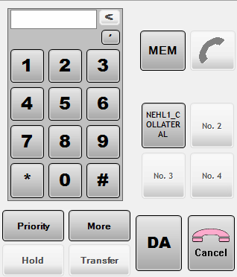

Figure 40. IA Control Window in FAA interfaces.

This window opens to make a call to a destination that is not preprogrammed (Dialling) or to open the destination book.

### Management of Recent Calls

This is made up of an area the allows users to memorise and manage the last four incoming and outgoing calls in the system, and that arrive through IA positions.

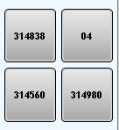

Figure 42. Recent Calls.

Each call will be identified by the caller number or identifier.

### Management of Outgoing Calls

Made up of the following fields:

* Alphanumeric Keypad. “PICK UP” Key. To activate Dialling.
* MEM key from the destination list of the position managed by a supervisor.
* Keys for the last four calls.

Alphanumeric keypad

This has the same structure as a telephone dial from 0-9 on an Alphanumeric Display that shows the digits and provides a button to delete the last digit entered with a short press or all of the digits by means of a long press.

The ‘,’ can be pressed at any time to indicate that the dialling should pause (for example to wait for a tone from a switchboard), as well as the special digits ‘\*’ and ‘#’.

The operation consists of entering the desired digits and then pressing the pick-up key. This key will remain deactivated if no digits have been entered in the display or if the digits entered are insufficient to make a call. When it is displayed on standby, the call can be made.

Prefixes

To make a call by indirect access, the first two digits to be dialled will correspond to the prefix of the network over which the call will be made[[2]](#footnote-2). There are two preset networks with the corresponding prefixes:

* PSTN Network. To make an outgoing call, dial the prefix 04 followed by the corresponding subscriber number.
* Secure Network. To make an outgoing call, dial the prefix 01, followed by the subscriber number.

MEM Key

When you press the MEM key, the key will change to ACTIVE status and a window will open with the user’s telephone directory that can be used to make outgoing calls.

The procedure consists of selecting one of the destinations from the directory, which will switch to the “function in progress” indication (yellow background) and then press the Accept key that has changed to standby, and the call will be made to the selected destination.

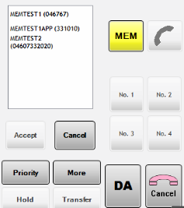

Figure 43. IA Page. MEM Key in FAA interfaces.

Info Key

The key is located on the General information panel or Header. This key opens a screen that provides access to two telephony utilities: the AGVN Numbering Plan and the local telephone call log.[[3]](#footnote-3)

## Dependencies-User

When you click the *Dependencies-User* button, a screen opens to display the defined areas of the AGVN plan. When you click on the Ids or use the direction keys at the bottom, you will move between countries, as shown in the figure on the next page:

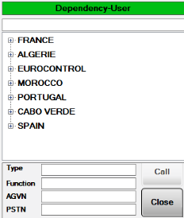

Figure 45. Directory of Dependencies and Users. Scenario 1 in ENAIRE interfaces.

If you select a country and expand the information, the FIRs that are in the Numbering Plan Tables will appear, as shown in the figure below:

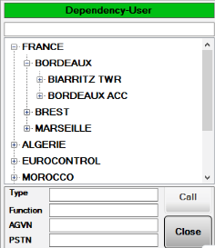

Figure 47. Directory of Dependencies and Users. Scenario 2 in FAA interfaces.

When one of the FIRs is selected, the Dependencies are displayed, as shown in the figure below:

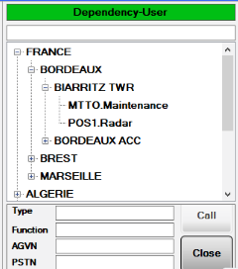

Figure 49. Directory of Dependencies and Users. Scenario 3 in FAA interfaces.

When you click one of the dependencies, the AGVN numbers and characteristics of the dependency will be displayed, along with the PSTN number, if applicable, as shown in the figure below:

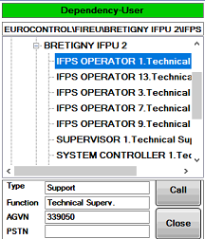

Figure 51. Directory of Dependencies and Users. Scenario 4 in ENAIRE interfaces.

When you reach this status, you can make a call to the user by clicking the “Call” button, or close the window by clicking “Close”. The “Close” key is always on standby to allow you to close the INFO window at any time.

### Call log[[4]](#footnote-4)

The INFO key provides access to the local log of telephone calls made by the operator. This log shows the result of the recent calls broken down into outgoing, incoming and unanswered calls, up to a maximum of ten records.

As shown in the figure, the information contained for each call is: Date/Time, access type (direct or indirect) and the collateral who made the call (in the case of incoming calls) or to whom the call was made (for outgoing or unanswered).

In addition, at the bottom of the call log window, the collateral of the last call corresponding to the selected call group is displayed.

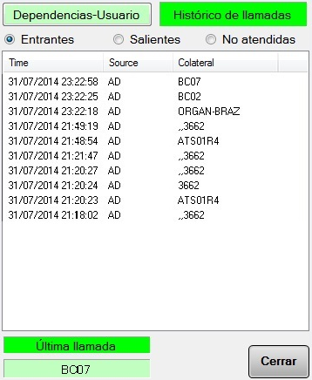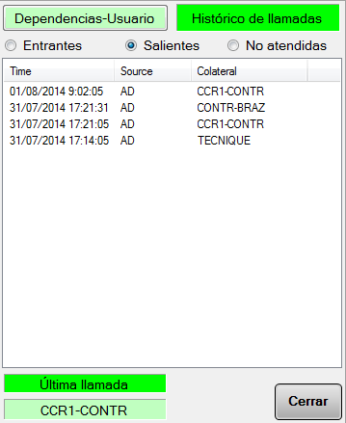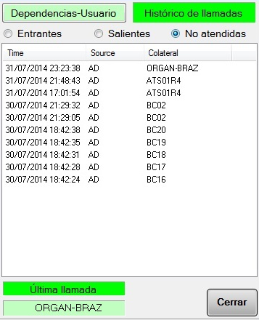

Figure 53. Log of incoming, outgoing and unanswered calls.

## Statuses of the PICK-UP key

The statuses associated with the ‘PICK UP’ key are shown in the table below:

|  |  |  |
| --- | --- | --- |
| **STATUS** | **COLOUR** | **VIEW** |
| Standby | Grey |  |
| Outgoing | Blue |  |
| Conversation | Green |  |
| Busy, Congestion or Blocked | Red or flashing red |  |
| No permission to make an outgoing call through the selected interface. | Yellow |  |

Table 18. Hang up / Pick up statuses.

## Volume Control Area

The telephone speaker or headset volume control is only shown if enabled in the installation options.

These are shown as red crosses if there is a fault in the speaker or it is disconnected.



### Volume of Hotline and Telephony Speaker

The adjustment of the hotline and telephony speaker volume is done using the following keys:

* Volume up key
* Volume down key
* Linear indicator of the current volume level

|  |  |
| --- | --- |
|  |  |
| Figure 54. Hotline Speaker Volume Control | Figure 55. Telephony Speaker Volume Control |

### Telephony Headset Volume

The headset volume is adjusted using the following keys:

* Volume up key
* Volume down key
* Linear indicator of the current volume level

This button will only be displayed if the speakers only mode is configured.



Figure 56. Volume Control of Telephony Headset

## Control of Pages in Direct Access Telephony

It consists of an access key for each one of the pages of DA telephone lines.

|  |  |
| --- | --- |
|  |  |
| Figure 57. Control of Telephony Pagination in ENAIRE interfaces. | Figure 58. Control of Telephony Pagination in ASECNA interfaces. |

The information that is provided by the page access key is colour coded.

* Standby Grey
* With activity, it will encode a colour sequence depending on the status of the collaterals in this page, according to the following table.
* If there are several statuses in the same page, the colour indication of the page will be handled in the following order:

|  |  |  |
| --- | --- | --- |
| **STATUS** | **COLOUR** | **VIEW[[5]](#footnote-5)** |
| Incoming Call | Flashing Orange |  |
| Priority Incoming Call | Rapid Flashing Orange |  |
| Outgoing Call | Blue |  |
| Conversation | Green |  |
| Busy | Red |  |
| Congestion | Flashing Red |  |
| On hold | Flashing Green |  |
| Memorised | Orange |  |

Table 19. Status of the Pagination Keys

# Hotline Operation

## Hotline Selection Area

This area allows you to individually select each one of the available Hotlines to facilitate the correct selection of the selected channel. The final arrangement of these keys will conform to the operational configuration of the panel. These keys do not interlock; i.e., to maintain a conversation, you will need to keep the Hotline key pressed.

Each key is divided into two parts:

* **TX Status Zone.** This occupies the top of the key and it displays an identification text (on two lines, 4 characters each) or representative icon for the associated line service.
* **RX Status Zone.** Occupies the bottom of the key.

The indication of the operational statuses of a particular hotline service is provided by changes in the colour of the different zones of the hotline key.

|  |  |  |  |
| --- | --- | --- | --- |
| **STATUS** | **VIEW** | **TX-ZONE** | **RX-ZONE** |
| Standby |  | GREY | GREY |
| Outgoing call (Tx) |  | GREEN | GREY |
| Incoming call (Rx) |  | GREY | GREEN |
| Two-way Communication |  | GREEN | GREEN |
| Called party busy |  | RED | GREY |
| Memorisation (call notification, when the user is busy) |  | GREY | Yellow |
| Cannot be selected (Malfunction) |  | LIGHT GREY WITH RED X | LIGHT GREY WITH RED X |

Table 20. Operational Statuses of Hotlines

The Incoming Call indication (RX zone of the HL key green) will be maintained for 5 seconds after the completion of the communication. This is to allow the operator to identify the calling party, if it was not possible to view the indicator during the communication while engaged in other tasks.

## Operation through Hotline

Communications that are established through Hotline are normally one-way, although two-way communications are possible. Hotline transmission inhibits radio transmission. Reception is always on the Hotline speaker. The following functions can be carried out:

* Transmission by Hotline
* Reception by Hotline

### Transmission by HL

Carry out the following sequence of actions to transmit through a HL:

|  |  |  |  |
| --- | --- | --- | --- |
| **STEP** | **ACTION** | **VIEW** | **RESPONSE** |
| 1 | Initial Conditions |  | At least one HL service configured |
| 2 | Press and hold HL key while talking |  | HL key Status, TX zone in “Outgoing Call” |
| 3 | Destination User Busy |  | TX Zone of HL key “Busy” |
| 4 | Destination User transmitting at the same time (Two-way Transmission) |  | TX Zone of HL key “Outgoing Call”  RX Zone of HL key “Incoming Call” |
| 5 | Malfunction on the Line |  | Red X on grey background |

Table 21. Procedure for Transmission by HL

### Reception by HL

The operator does not have to initiate any sequence to receive audio. The indications on the panel follow the following sequence:

|  |  |  |  |
| --- | --- | --- | --- |
| **STEP** | **ACTION** | **VIEW** | **RESPONSE** |
| 1 | Initial Conditions |  | At least one HL service configured |
| 2 | A call is received |  | RX Zone of HL key “Incoming Call”.  The audio is received directly on the speaker.  The incoming call indication is maintained for a time (configurable) after the end of the communication. |
| 3 | User presses HL key and transmits at the same time (Two-way Transmission) |  | TX Zone of HL key “Outgoing Call”  RX Zone of HL key “Incoming Call” |
| 4 | Call not accepted (user transmitting over another HL, Busy status) |  | RX Zone of HL key “Memorisation”.  The “Memorisation” indicator is maintained until it is acknowledged by the user. |

Table 22. Procedure for Reception by HL

# Special Functions[[6]](#footnote-6)

Special functions are functions that are not communications but that are used to provide assistance and security to the operator’s work.

## Local recording on terminal

This function makes it possible to locally record and replay all voice communications made on the position in the last thirty (30) minutes. This function can be configured on each position by the System Supervisor.

The recordings are organised by sessions, indicating the date and time of the end of the recording, its duration and the session to which it corresponds.

The recording log will be deleted when the terminal is rebooted and when a new sectorisation is received.

### Session Recording

Provided that the Sector has been configured by the System Supervisor with the Recording Function, all of the terminal’s audio sessions will be recorded automatically.

Sessions may be:

* Radio Reception. Recording begins and ends with the presence or not of SQL; if there is more than one channel in RX with SQL, the session starts with the first SQL and ends with the last one.
* Radio Transmission. Recording begins and ends with the PTT action.
* Telephone Conversation. Recording begins and ends with the conversation status and end of the conversation on the terminal.
* Hotline Reception. Recording continues during call reception.
* Hotline Transmission. Recording continues during call transmission.
* BRIEFING function. Recording continues while the BRIEFING function is active.

### Session Replay

To play back sessions, the user presses the REPRODUCTION button that is located in the Telephony Functions zone, see figure 21, page 24. When the REPRODUCTION key is pressed, the following window opens:

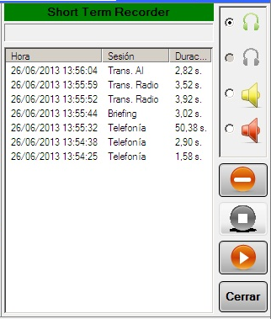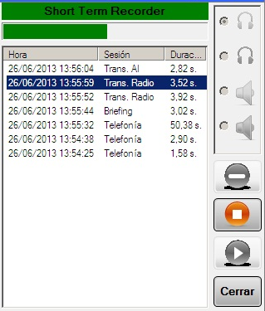

Figure 59. Local Replay on the Terminal, Standby and Replay

A bar is displayed at the top to indicate the replay status.

The central screen shows all of the audio sessions recorded on the terminal, indicating the date and time when the session recording finished, the type of session to which it belongs and its duration.

The following are displayed on the right side of the window, from top to bottom:

* A box that contains the audio devices that can be used for replay - executive headset, assistant headset, Radio speaker and Hotline speaker. The replay medium cannot be changed during replay.
* Delete button. Allows the selected session to be deleted.
* End Replay Button. Ends the replay in progress.
* Replay Button. Begins the replay of the selected file.
* Close Key. Closes the Local Replay on Terminal function.

If, during session replay, PTT is pressed or a Transmission by Hotline is done, the replay will stop automatically and the Replay Function will close.

The Close button shows the telephony activity indicator, just like the DA and IA keys in table 13, page 27.

## BRIEFING function

The BRIEFING function consists of a mechanism for recording the status of the terminal and the environment that it controls during the operator switchovers. The information recorded is voice information (audio).

The general information panel contains the BRIEFING key, as shown in the figure below:

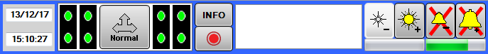

Figure 60. BRIEFING Function

When you press the BRIEFING key, a message opens with two buttons, Accept or Cancel. If you click Accept, the BRIEFING session indicated in the messages window will begin.

When you press the key again, the recording and BRIEFING function will close. This session will also close automatically if:

* PTT is pressed.
* If a TX Hotline call is made.
* If an outgoing telephone call is made.
* After thirty (30) seconds of activity of the function.

# Legal Information

**Open-source licences**

|  |  |  |  |  |  |  |
| --- | --- | --- | --- | --- | --- | --- |
| **OPEN SOURCE CODE SOFTWARE** | **VERSION** | **COPYING** | **COPYING.**  **LESSER** | **COPYING.**  **AFFERO** | **LICENSE** | **URL DOWNLOAD** |
| MySQL Database Community Edition | 5.6.11 | X |  |  | GPL v2.0 | <https://www.mysql.com/products/community> |
| Runtime Crystal Reports | 13.0.9 |  |  |  | Free Internal Distribution | https://wiki.scn.sap.com |
| NLOG | 4.2.3 | X |  |  | BSD-3-Clause | https://www.nuget.org/packages/NLog/4.2.3 |
| WebSocket4Net | 0.14.1 | X |  |  | Apache-2.0 | https://www.nuget.org/packages/WebSocket4Net/ |
| JSON.NET | 7.0.1 | X |  |  | MIT | https://www.nuget.org/packages/Newtonsoft.Json/7.0.1 |
| #Snmp Library | 8.5.0.0 | X |  |  | MIT | https://www.nuget.org/packages/Lextm.SharpSnmpLib/8.5.0 |
| PJ-SIP | 1.6 | X |  |  | GPL v2.0 | <http://www.pjsip.org/download.htm> |
| Spread toolkit | 4.4.0 | X |  |  | Spread Open-Source | <http://www.spread.org/download.html> |
| ASIO | 2.10 | X |  |  | Particular license | <http://www.asio4all.com/> |
| NLOG | 3.1.0.0 | X |  |  | BSD-3-Clause | https://www.nuget.org/packages/NLog/3.1.0 |
| JSON.NET | 8.0.2 | X |  |  | MIT | https://www.nuget.org/packages/Newtonsoft.Json/8.0.2 |
| #Snmp Library | 7.0.0.1 | X |  |  | MIT | https://www.nuget.org/packages/Lextm.SharpSnmpLib/7.0.0.2 |
| INI.Parser | 2.3.0 | X |  |  | MIT | https://www.nuget.org/packages/ini-parser/2.3.0 |
| Naudio | 1.7.3 | X |  |  | MS-PL | https://www.nuget.org/packages/NAudio/1.7.3 |
| O.S. Yellow Dog | 2.4.1 | X | X |  | GPL v2.0, LGPL v.2.1 | http://www.fixstars.com/en/technologies/linux/ |
| oSip Library | 2.3.5 |  | X |  | LGPL v3 | <ftp://ftp.gnu.org/gnu/osip> |
| xOSip Library | 2.3.5 | X |  |  | GPL v2.0 | <http://download.savannah.nongnu.org/releases/exosip/> |
| jRtp Library | 3.7.1 | X |  |  | MIT | http://research.edm.uhasselt.be/jori/page/CS/Jrtplib.html |
| Snmp++ Library | 3.3.1 | X |  |  | Particular license | http://agentpp.com/download.html |
| Agent++ Library | 4.0.2 | X |  |  | Apache 2 Open Source | http://agentpp.com/download.html |
| mongoose server | 5.6 | X |  |  | GPL v2.0 | https://github.com/cesanta/mongoose/releases/tag/5.6 |
| Rapid-Json | 1.0.2 | X |  |  | MIT | https://www.nuget.org/packages/rapidjson/1.0.2 |
| Rapid-xml | 1.13 | X |  |  | BSL-1.0/MIT | <https://www.nuget.org/packages/rapidxml/1.13.0> |
| jQuery | 2.1.3 | X |  |  | [MIT/Boost Software License](https://jquery.org/license/) | https://code.jquery.com/jquery/ |
| Angular JS | 1.5.3 | X |  |  | MIT | https://code.angularjs.org/1.5.3/ |
| Bootstrap | 3.3.5 | X |  |  | MIT | https://github.com/twbs/bootstrap#copyright-and-license |
| Virtual Box | 5.0.0 | X |  |  | GPL v2.0 | https://www.virtualbox.org/wiki/Download\_Old\_Builds\_5\_0 |

**Licences in COPYING, COPYING.LESSER and/or COPYING.AFFERO.**

|  |  |
| --- | --- |
|  |  |
| **COPYING** |  |
| **COPYING.LESSER** |  |
| **COPYING AUTHORIZATION** |  |

# GLOSSARY

|  |  |
| --- | --- |
| **A/G** | Air / Ground |
| **ACC** | Area Control Centre |
| **DA** | Direct Access |
| **IA** | Indirect Access |
| **ATM** | Air Traffic Management |
| **ATS** | Air Traffic System |
| **ATS-N5** | UIT-N5 Protocol for ATS |
| **ATS-QSIG** | QSIG protocol in ATS systems |
| **ATS-R2** | R2 protocol in ATS systems |
| **CB** | Central Battery |
| **LB** | Local Battery |
| **BROADCAST** | Means of transmitting to all devices on a network |
| **CELP** | Code excited linear prediction. Voice encoding algorithm |
| **CODEC** | Encoder-Decoder |
| **COTS** | Commercial Off The Shelf |
| **CPU** | Central Processing Unit |
| **DTMF** | Dual-tone multi-frequency signalling. Analogue Telephony Protocol |
| **ETHERNET** | LAN networks standard |
| **ETM** | Multi-protocol Test Equipment |
| **ETSI** | European Telecommunications Standards Institute |
| **EUROCAE** | European Organization for Civil Aviation Equipment |
| **FULL-DUPLEX** | Simultaneous send and receive transmission mode |
| **FXO** | Foreign eXchange Office. Subscriber mode telephone interface. |
| **FXS** | Foreign eXchange Station. Central Mode Telephone Interface |
| **HF** | High Frequency. Electromagnetic spectrum band in the frequency range of 3 MHz to 30 MHz |
| **HMI** | Human Machine Interface |
| **HTTP** | Hypertext Transfer Protocol |
| **IP** | Internet Protocol. Basic communications protocol |
| **IPDV** | IP PACKET DELAY VARIATION. See JITTER |
| **JITTER** | Deviation or displacement in a periodic parameter of a signal. |
| **LAN** | Local Area Network |
| **NEHL** | Normalised External Hotline |
| **LD-CELP** | Low-Delay Code Excited Linear Prediction |
| **MEDIA** | Information contained in a transmission |
| **MULTICAST** | Information sent over a network to multiple destinations simultaneously |
| **NTP** | Network Time Protocol. Network synchronisation protocol |
| **ICAO** | International Civil Aviation Organisation |
| **PABX** | Private Automatic Branch Exchange. Telephone exchange |
| **PROXY** | Program or device that performs an action in representation of another |
| **ERSS** | Equipment Room Supervision Station |
| **ORSS** | Operations Rooms Supervision Station |
| **PTT** | Push to talk |
| **QSIG** | ISDN-based Telephony Signalling Protocol |
| **RAM** | Random Access Memory |
| **ISDN** | Integrated Services Digital Network |
| **ISDN-B** | Integrated Services Digital Network Basic Interface. |
| **RFC** | Request for Comments |
| **RTCP** | Real time control protocol. RTP sessions control |
| **RTP** | Real-time Transport Protocol. Protocol for transporting data over IP |
| **SACTA** | Automated Air Traffic Control System of Enaire |
| **VCS** | Voice Communications System |
| **SDP** | Session Description Protocol |
| **SIP** | Session Initiation Protocol. Session Management Protocol over IP |
| **SNIFFER** | Software or Hardware element that can intercept and log data network traffic |
| **SNMP** | Simple Network Management Protocol. IP networks Management Protocol |
| **SOAP** | Simple Object Access Protocol |
| **SQUELCH** | Indicates presence of a Valid Signal in Radio Reception |
| **G/G** | Ground / Ground |
| **TACC** | Terminal Area Control Centre |
| **TCP** | Transmission Control Protocol |
| **TWR** | Control Tower |
| **SCU** | Sector Control Unit |
| **UDP** | User Datagram Protocol |
| **UHF** | Ultra-High Frequency. Electromagnetic spectrum band in the frequency range of 300 MHz to 3 GHz. |
| **UIT-T** | UIT Telecommunications Standardisation Sector |
| **UNICAST** | Means of sending information from a single sender to a single recipient |
| **USB** | Universal Serial Bus |
| **VHF** | Very High Frequency. Electromagnetic spectrum band in the frequency range of 30 MHz to 300 MHz |
| **VoIP** | Voice over IP. Technology for transmitting audio signals in IP data packets |
| **WAN** | Wide Area Network |
| **WEB** | World Wide Web. System of documents connected by hypertext links, available on a network. |
| **XML** | Extensible Markup Language |

Table 23. Glossary of Abbreviations

1. Only in ASECNA interfaces. [↑](#footnote-ref-1)
2. Except for ATS network calls, for which the subscriber number will be dialled without a prefix. [↑](#footnote-ref-2)
3. Only in ASECNA interfaces. [↑](#footnote-ref-3)
4. Only in ASECNA interfaces. [↑](#footnote-ref-4)
5. This table shows only the graphics that correspond to the pagination control format used in the ASECNA interface. [↑](#footnote-ref-5)
6. Only accessible in the ASECNA interface. [↑](#footnote-ref-6)